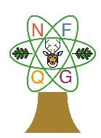
New Forest Quilt Group
Newsletter June 2020

Chair’s Chat

Here we are, two months into Lockdown and still no prospect we can meet as a group. The Community Centre is closed and likely to remain so for a while, as most of its members are pensioners. It must be particularly hard for many of these retired folk at the moment, unless, like us, they have an absorbing hobby!

The Committee have been having Zoom Committee Meetings during this crisis. Janella noticed it was Tommie McNair’s 90th birthday so we sent her some flowers from all of you. I even took her a card round and sang happy birthday on the doorstep!

I, for one, have enjoyed the time to do lots of Patchwork. As no-one else is allowed through the door, my husband Chris has even allowed me to keep my sewing machine out on our dining table. What a help that is. So far, I have finished the reverse appliqué from a workshop and a half finished bag.

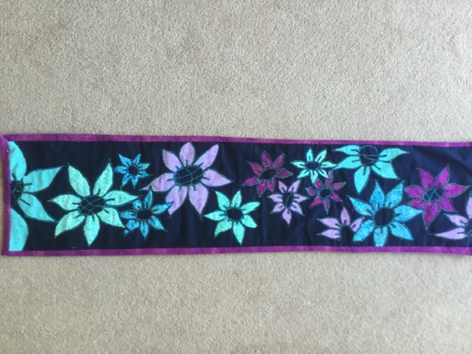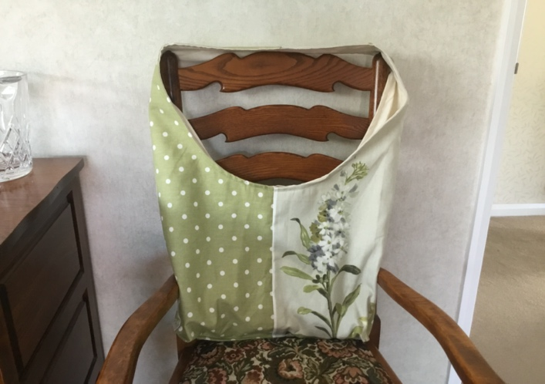

I have thoroughly enjoyed the Journal Quilt Challenge and my first yellow (July, so I am ahead of the game for once).

This has made me almost finish a table centre for which my lovely sister-in-law gave me the pattern. Just the edge to put on now.

The table runner is a really good way to use up scraps, especially on the triangle with graded strips.

If anyone needs advice on how to make one, I am very happy to help.

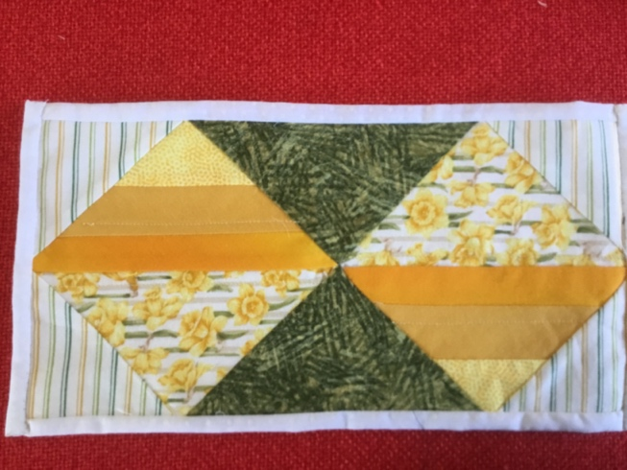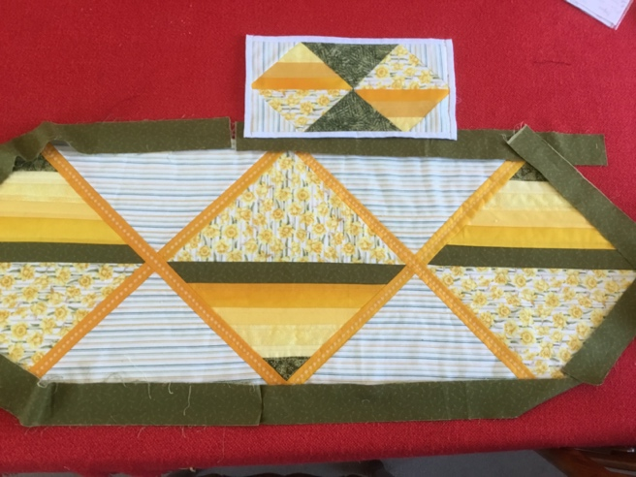

If anyone needs help at all, please get in touch. The Committee work as a team and we are well spread out in different areas. Finally please keep safe. See you all as soon as possible.

Jenny

**************************************************

From Speakers” Corner….

At the time of writing we hear that the government is lifting some of the restrictions on meeting up with friends and family from Monday 1st June, and some public places and events will start to open their doors again.

Whilst this is wonderful news for those of us who have been isolating and are desperate to see our children and friends, it doesn’t make much of a difference in terms of social events and activities where social distancing and “keeping alert” is likely to prove problematical, if not downright impossible! Like our monthly Quilt Group meetings for example…….

At our Zoom committee meeting this week, we very sadly decided that we must formally cancel our meeting and workshop in July. The safety of our members is always our main priority, but we are also mindful of your comfort and enjoyment – even if we were permitted to hold the meeting by limiting the number of members attending, placing chairs 2 metres apart, using hand sanitiser etc. we feel our usual experience of pleasure and friendship would be lost.

We were due to welcome Fran Holmes to speak in July:

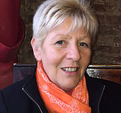
An experienced textile artist with a level 3 machine embroidery diploma and level 3 diploma in creative techniques in textiles (distinction.) Fran’s work has been exhibited at the NEC, Excel, West Country Quilt Show and The Big Textile Show over the past 10 years as well as other galleries around the UK including the Lake District and Oxford University. Belonging to the Textile Art Groups Meniscus, Drawn to Stitch and Inspire has helped Fran to further develop her machine embroidery skills.

Fran’s workshop on 7th July was on “Serviette Quilting” – a technique she has developed using “posh” paper serviettes backed with stabiliser and fleece and embellished with hand or machine embroidery and beads.

Please do check out Fran’s work on her website (franholmes.com) or on Pinterest or Twitter (@franholmesarts)

We will make every effort to rebook Fran next year.

The committee will “meet” next month to discuss what to do about future meetings – by then we hope the government will have a clear route plan for the re-opening of larger social gatherings and who knows, we may see you in August. Watch this space!

Keep safe everyone, and keep quilting. (When we do get to meet again, Show and Tell will be amazing!)

Sandown Park Coach Trip cancelled

Finally, Pat McKean has confirmed that the Sandown Park trip is cancelled as the show has been cancelled in June. Whilst it is currently re-scheduled for the end of November, there won’t be a coach trip then, even if it goes ahead.

We will look forward to there being a show in 2021.

Terry and Eddie

***********************************************************

This week I have mostly been……Eco-Dyeing! By Terry Loader

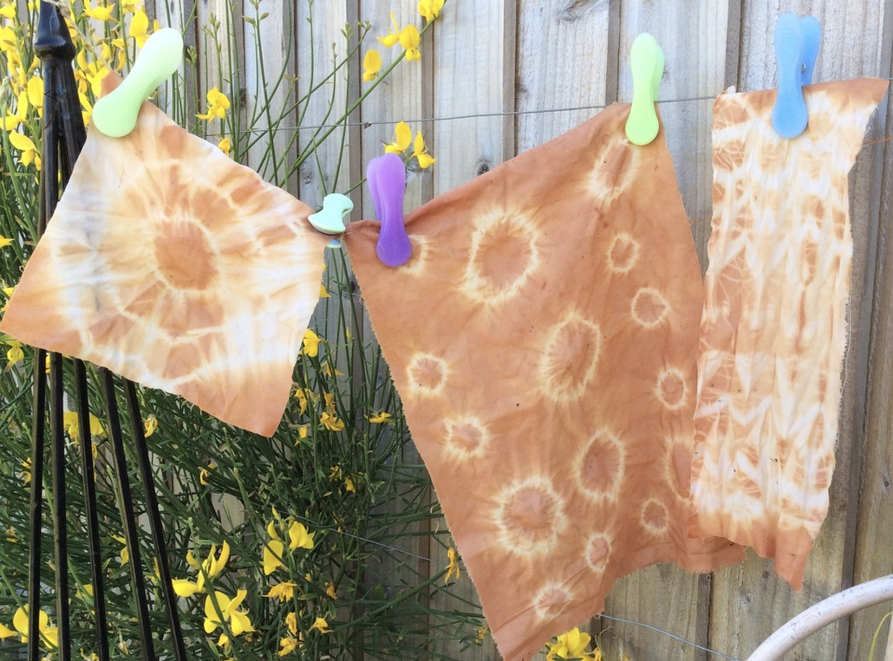
This is a really simple way of producing unique pieces of fabric for your projects. Boil onion skins (the dry bits, no flesh as this is very smelly…!) for an hour or two, strain and cool and pour into a jam jar (I used the large Hellmann’s mayonnaise jars, but anything with a tight lid will do).

Take some pieces of fabric and do your old ‘70s tie dyeing techniques – I used buttons, large beads and strong Perle thread to wrap and tie the fabric. Stuff the tied and twisted fabric into the jar, screw on the lid tightly and put in a safe place for a day or two.

After a couple of days, take out the fabric twists, and let them dry in the sun. Remove all your threads and buttons etc, rinse very briefly in cold water (this is not a permanent dye so you don’t want to wash it all away), dry in the sun, then iron. Then let your creative urges flow! - I’m thinking of embroidering and embellishing mine to make Tibetan prayer flags. Experiment with different natural dyes; turmeric is good, beetroot for a nice pink, nettles maybe? Enjoy.

Terry Loader

***********************************************************

A view of Lockdown 2020 – by Maureen Stringer

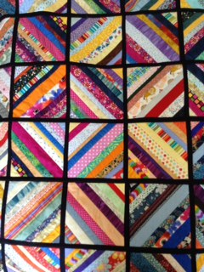
How thankful I am for two things: the garden and patchwork! The garden has changed from the lovely freshness of spring to the more vibrant colours of summer, though I’m sadly missing some of the bedding plants I’d normally buy. A number of birds nested in the garden, now the young ones are enjoying the pond and waterfall – and I’ve had time just to sit and watch!Maybe like me some of you, are struggling with the social isolation and lack of people time - patchwork has been a bit of a life saver!

At the start of lockdown I decided now was a good time to get rid of some of those UFO’s and use up some of my stash!!

I finished this Quilt for Care Leavers at the beginning of Lockdown; one UFO finished!!

It’s one of those with the interesting (!!) way of joining squares. I’m pleased to have done it but don’t think I will do it again, willingly!!

At least it is colourful and used up some of my scraps.

Continuing with the need to use up some scraps I wanted to try this pattern that one of the ladies had done for Q4CLs.

It’s from the Missouri Star Quilt Company website and is The 3-Dudes quilt
This is just the quilt top as I don’t have space to quilt such large pieces. I’ll pass it to Eleanor with the backing piece I was given and hopefully one of her contacts will be able to quilt it.
I tried to photograph this on the washing line – unfortunately there was a bit of a breeze and it’s a bit blurred!

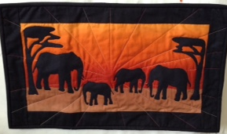
The next project: some years ago a lady was clearing out her patterns and fabric and gave me bits towards this wall hanging – I’ll admit I forgot about the wall hanging bit so will need to add a sleeve or something later!

There are other templates in this series; I did enjoy doing this one.

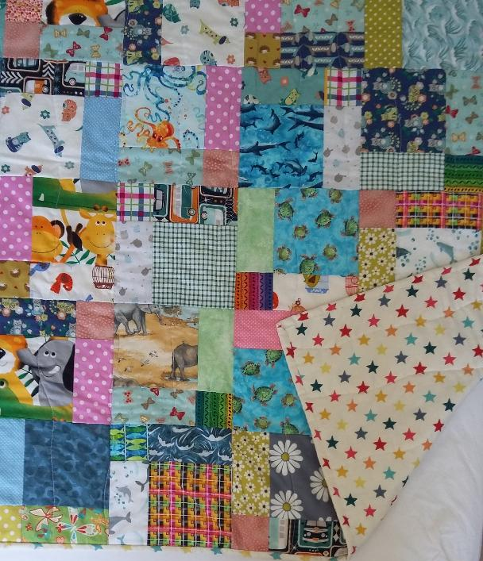
Then it was back to some charity quilts – these will be for Linus.

I was still hoping to deplete my stash, except of course a quilt rarely uses much of one’s material!

This is a disappearing 9-patch using 5” squares rather than the usual 2 ½”. I have quite a lot of novelty fabrics and thought any picture would be lost in a smaller square - but it did mean I had to be aware of the orientation of the corner squares of the 9-Patch when sewing together to keep them going the right way when cut up!

I bought a pack of Fat Quarters from Nicola’s stall at the Quilt Exhibition we had. Various London related images which brought back memories of 30 years or so living in North London and working in the City (in case you wondered, there is no hankering to get back there!)

Again it was important to have reasonably sized squares to capture the images so these are 6 ½” squares randomly sewn together. The backing is made out of fabric scraps I’d cut or sewn into 6 ½” squares so it could be double sided.
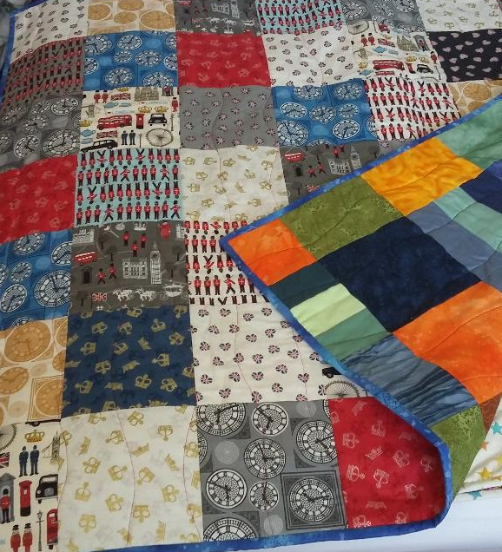

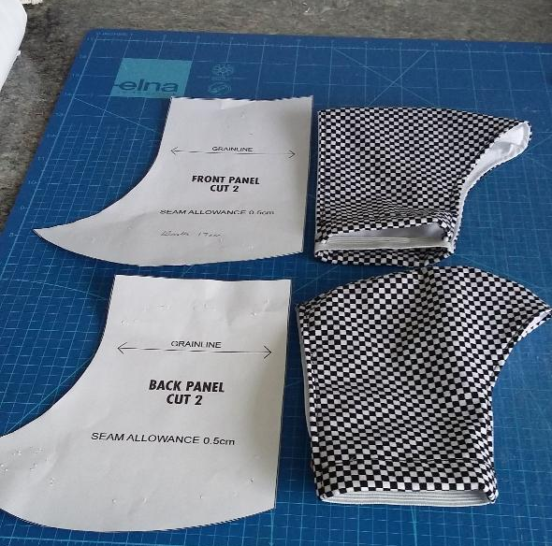
I have made some Facemasks – one of the projects we are doing to support the Members and friends of St Mark’s.

I chose this simple pattern I saw on The Sewing Bee .

Other people are making the more conventional ones with the pleated front. Having made these and worn one now – I was surprised how warm it is and my glasses get steamed up!!

However, back to some fun sewing and my current project
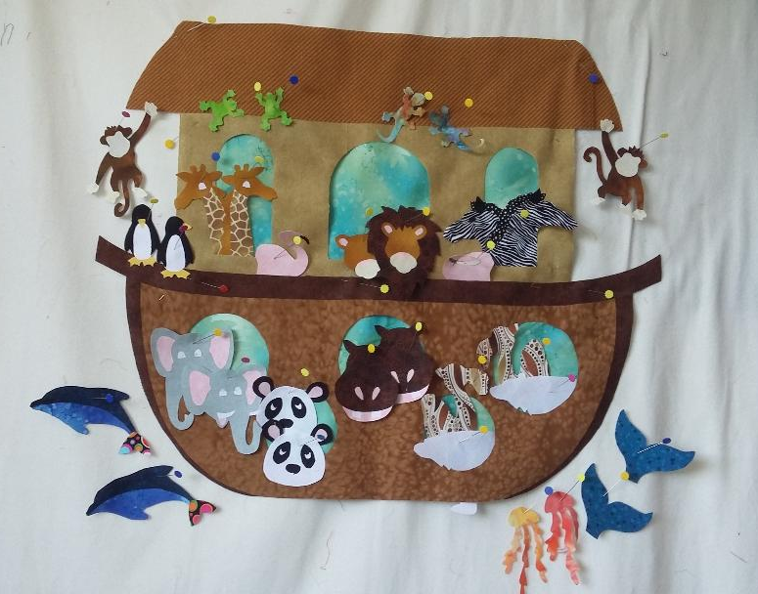
This is from Gail Lawther’s book Noah’s Ark and before anyone asks, I will not be zigzagging around each animal!! It will be quilted in the Gail Lawther way with embellishments where appropriate

The sea and sky are ready for this to be appliquéd on to but there are a few more things to be created first, some birds for example!

So, ten weeks into self distancing - I’m minus one UFO and my stash has been very slightly reduced, but I’m guessing there are a few more weeks before I get back to other things again so maybe another project or two to try and reduce that stash!

Maureen Stringer

**********************************************************

The story of a modern day scrubber by Liz Gibson
Like many people, when the Coronovirus crisis developed and news came out about the difficulties faced by hospitals and care-homes due to a PPE shortage, I wanted do something positive to help. I was dismayed that the medical and care staff who were risking their lives daily on the frontline were so badly let down by the lack of basic protective clothing leaving them so vulnerable to infection.

I was in the shielding category with a lot of time on my hands and found a post on Facebook asking for local people to sew scrub bags for the hospitals so that staff could carry their uniforms home safely for laundering without risk of passing on infection. This was perfect for me as a very keen sewer and so production began in earnest. Duvet covers, sheets, pillow cases etc were donated to the cause and many hundreds of beautiful drawstring bags were made by local people and distributed to hospitals, care homes, community nursing teams etc.

A Facebook group “New Forest sewing for the NHS” was formed and soon there was a request for “competent sewers” to start making scrubs as these were in short supply. Many medical staff were often having to change their scrubs several times a day when working with Covid patients and there was a need for scrubs in the care homes where they are not normally worn so supplies were running out. I volunteered, along with a few other women, mainly in Sway. We were each delivered one set of scrubs to make as a trial and from that small acorn, a huge oak tree grew. Soon there were over thirty people around the New Forest sewing scrubs. We were split into small geographical Hubs with our own messenger groups and we were each given three sets at a time to sew, and once completed, another three sets were given to us. Initially the pieces were cut out by hand but now a local Sail production company is precision cutting them out using their laser cutter. They are in various colours – blue and white stripe, green and white stripe, yellow and white stripe, blue, black, green etc and we soon all became experts at patch pockets, side pockets, mitred corners, vents, facings, labels etc.

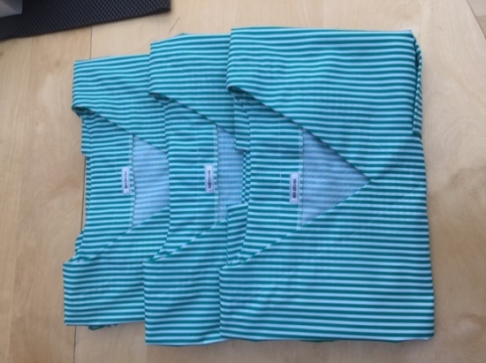
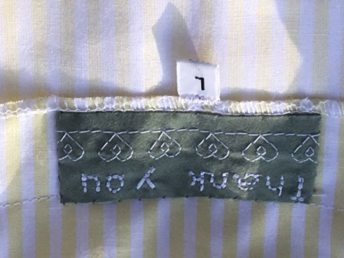
Now production has increased again with around 60 people busy at their sewing machines sewing scrubs for the NHS and social care sector. A YouTube video was produced showing the best way to sew the scrubs together and we all learned a few new tricks from that. Some of us make special labels to go in the scrubs to give the recipients a boost; others sew patterns onto them to brighten them up.

There are now around 60 people across the New Forest sewing scrubs and we have produced and distributed over 100 sets of scrubs each week to hospitals, care homes, community staff, mental health units to name a few. It is wonderful to receive photos from those using the scrubs and know that they are appreciated and well used.

At the same time, 50 other members of the Facebook group have been mass producing moisture resistant gowns for use by hospital staff as there was a critical shortage of these too and they are essential to staff for infection control. Over 17000 of these have been produced by the group, initially from the NFDC recycling sacks and more recently from plastic, donated and pre-cut by local companies and “welded together” by our members using a domestic iron. A true labour of love in the recent hot weather.

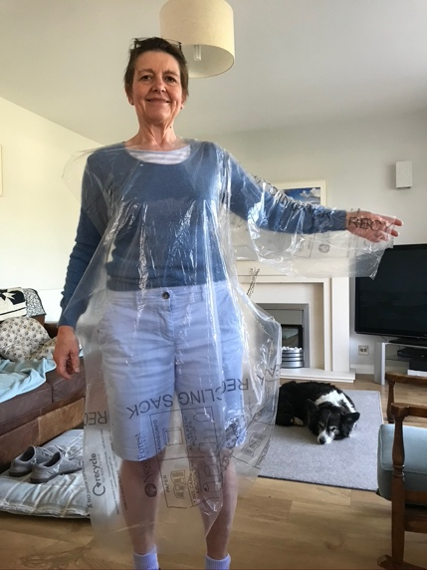

Alongside these two big initiatives, many people across the forest have been sewing scrub bags, headbands with buttons to help those wearing masks for long periods, scrub hats and recently, facemasks. There have been continual requests for these from health and social care workers throughout the Covid crisis. More recently with news of schools and pre-schools reopening, we have received requests for protective aprons for the staff and some masks for staff and children and these are now in production.

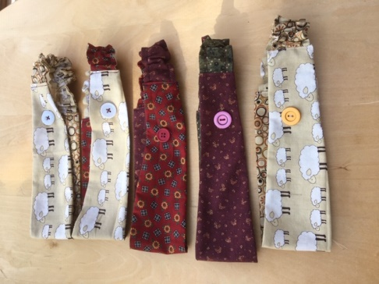
The whole operation has been amazing and I am so proud to have played a small part in it. Initially set up by one person, it has been well planned and organised from the start. There is now a very active admin team dealing with the logistics of production, distribution, fund raising, transport etc. So many different people, companies, voluntary groups etc. are now involved that it is a true community project.

There are volunteers delivering and collecting materials and completed items, local drop off points in each town, local companies providing valuable cutting services for fabric and plastic, local sewing groups forming messenger groups for support and discussions, local fabric shops giving large discounts on thread etc.

There is a “Just giving” page that has received over £5000 donations to enable us to buy fabric, threads etc for our scrubs and we were even on South Today, a video of this is on the Facebook page. I have loved being part of this sewing community, spending my days sewing whilst listening to ClassicFM or an audiobook has been a joy and even when things do go slightly wrong – I once sewed the side pockets into the trousers upside down – we have our sewing hub to support us.

There has been so much cooperation and support, it has really proved how people can come together in a crisis for the greater good. It has been a bright light at an otherwise dark time that has served to help not only the NHS and Care sector but also those lucky enough to have been involved in it.

***********************************************************

Scrub Hats by Susan Bugler
A phone call from our daughter prompted a quick turnaround for 24 scrub hats. They were fortunate that they already had masks and gowns. The reason was Claire was asked to set up a temporary mortuary at Brighton and Sussex Medical School where she is Head of Anatomy. They used their existing buildings and the Army set up further tented accommodation.
Claire sent a hat, so pattern drafted and with a very random selection of fabric, soon got into the swing! A very small contribution compared to the number of items many of you have made.

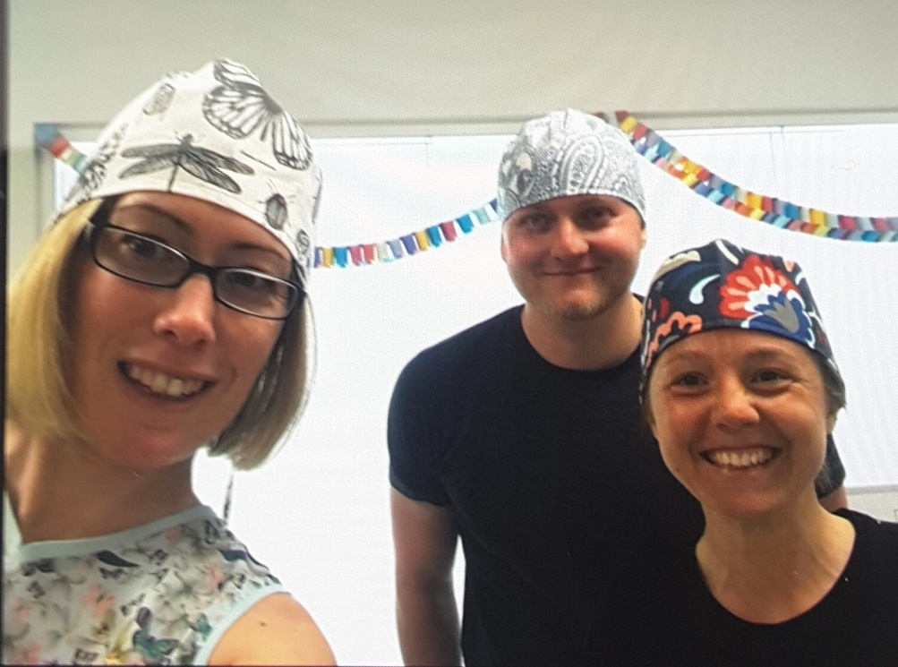

***************************************************************************
Take Three Girls….

Or more accurately, three highly respected female textile artists!

In November 2017 I popped into the Bridport Arts Centre to see the Marshwood Vale Arts Awards exhibition. Amongst the usual array of sculptures, oils and watercolours there was a beautiful textile piece by an quilter who I later discovered is a renowned and well-respected textile artist – Alicia Merrett. I was amazed by her use of colour and intricate piecing used in this piece called ‘Blue Harbour’ which is part of her Mapping the Imagination series of real and fantasy maps.

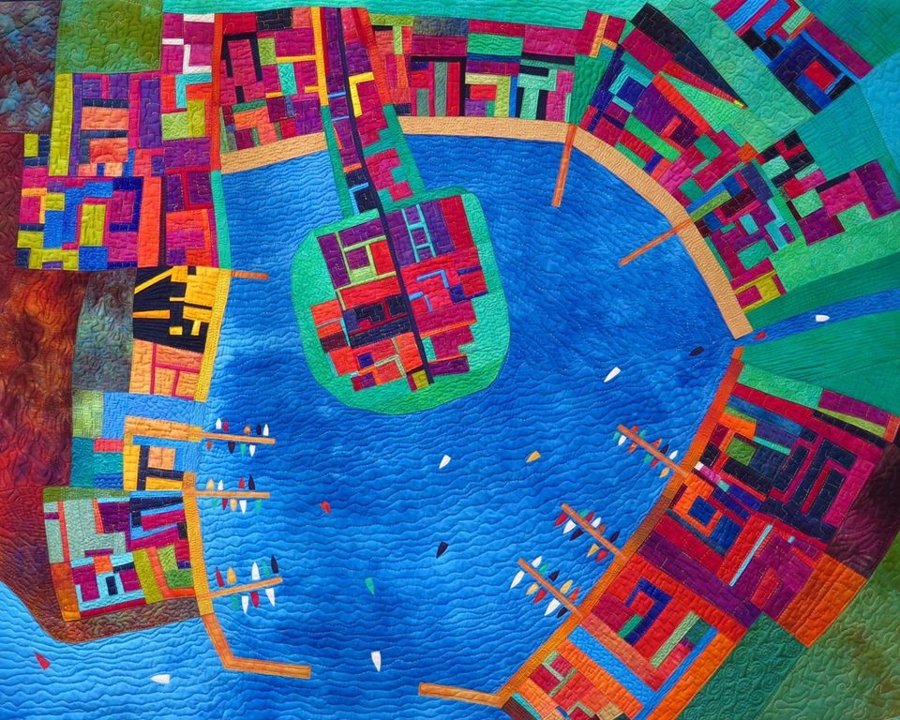

I was lucky to be able to visit Glastonbury in January 2018 where three artists had been commissioned to recreate and interpret aspects of the Abbey in different media – Alicia had produced some beautiful and unusual pieces which really added to a lovely day wandering the grounds of the Abbey, and poking around in all the unusual witchcraft shops and independent cafes!

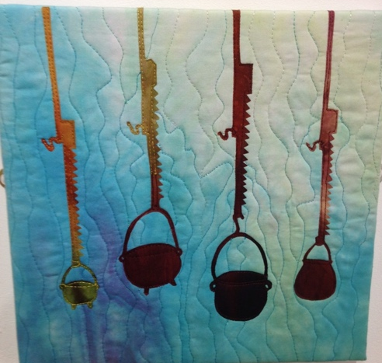
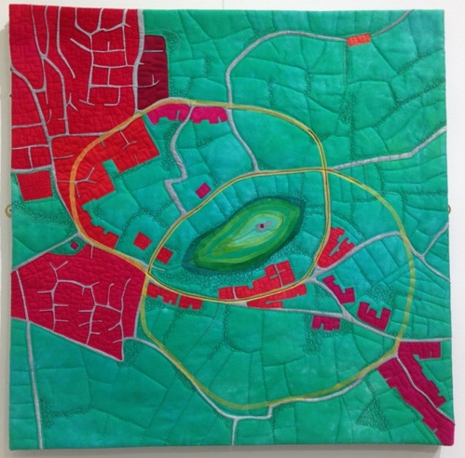
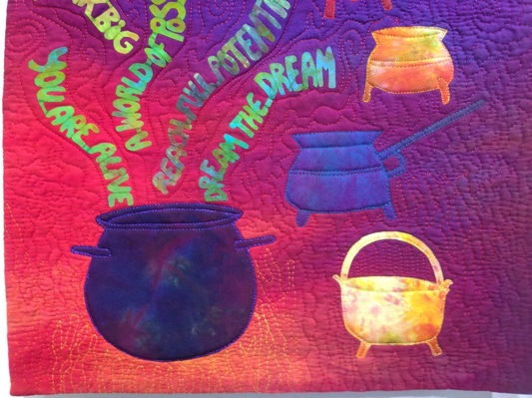

I was, by now, a complete Alicia-addict and was delighted to learn that she was facilitating a workshop at the Festival of Quilts in 2019. They say you should never meet your idols but Alicia turned out to be an absolute delight; funny, friendly, approachable and so willing to share her techniques and inspirations. And what an interesting life she has had – she studied Sociology and Anthropology, moved from Argentina to England, worked, had a family, studied photography, and eventually became a dollmaker and toymaker for 15 years (she has published books on this subject). She discovered quilting in the 1990s and her work is both innovative and accessible. Her latest creations are produced on her iPad, printed onto fabric and quilted. I urge you to check out her website!

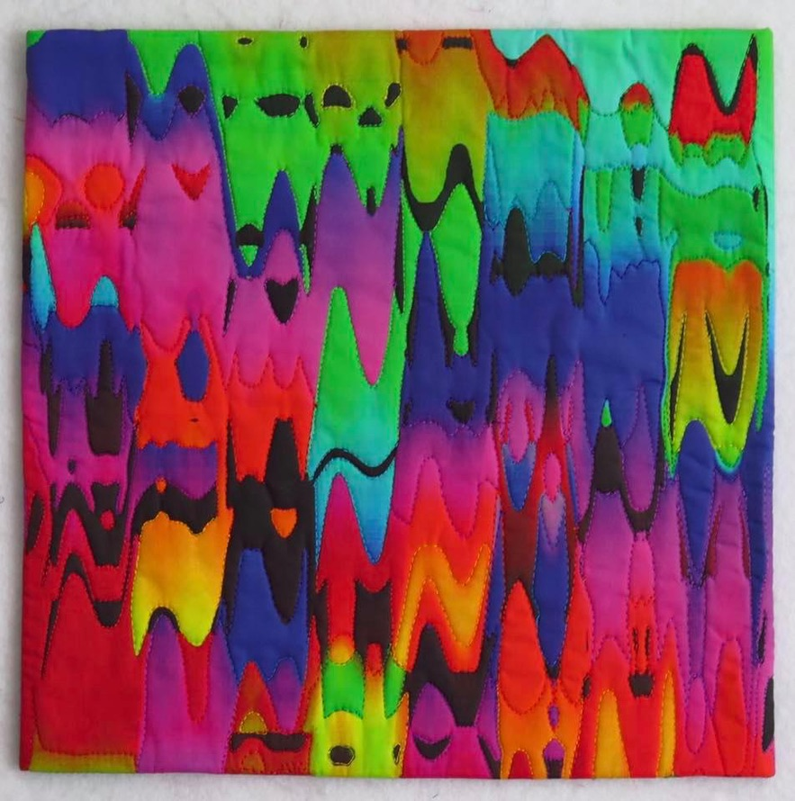

So back to the Festival of Quilts….! One quilt really caught my attention, a piece by Alexandra Kingswell. Like Alicia Merrett, Alexandra uses strong plain solid colours in her work.
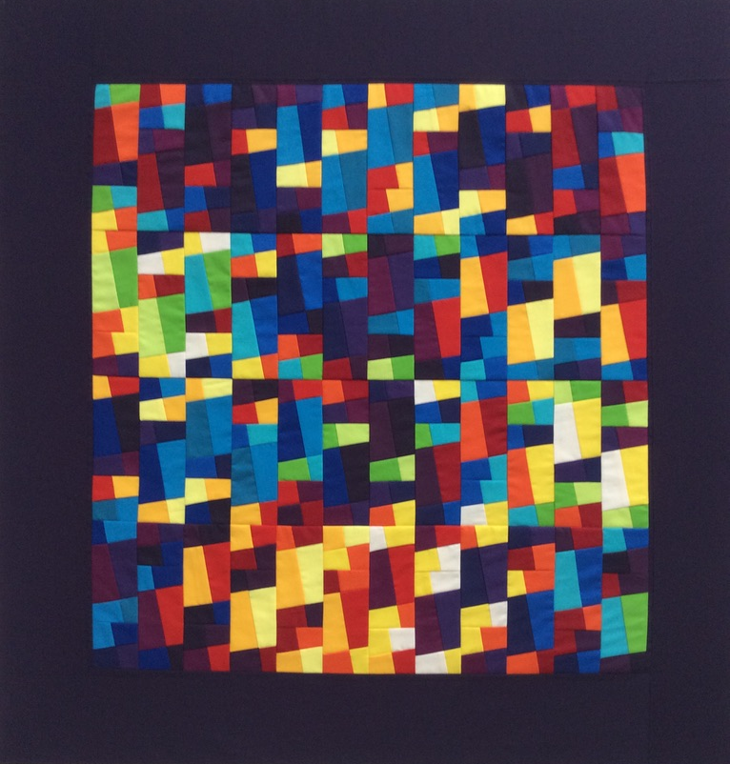

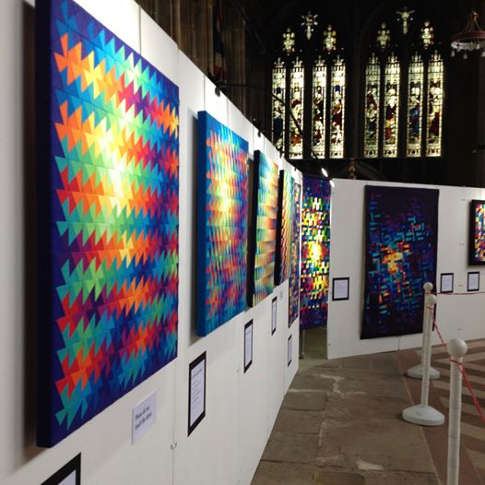
Alexandra’s background is in communications design and she worked as a graphic designer, discovering a love of textiles which is now her full-time occupation. She has a particular fascination with the “intricacies of number” and uses mathematical formulae, especially Pi, in her designs.

I love the way her work seems to be almost backlit, with a stained glass window quality, as shown in her exhibition Let the Light Shine" at St Mary's Church in Nottingham's Lace Market.

So now I was on the verge of developing a whole new addiction!

And just when I thought I had reached quilting-groupie perfection, with a workshop by Alicia Merrett and a new love discovered in Alexandra Kingswell, I popped into the bookshop at the festival and this book leapt off the shelf!

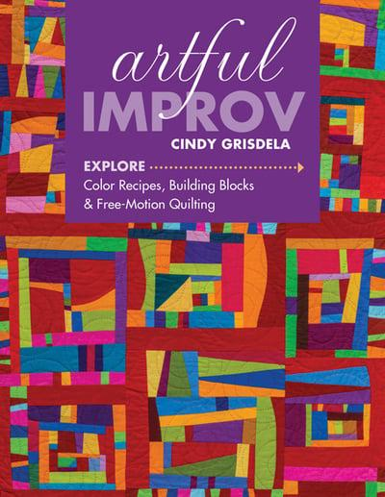
Cindy describes herself as a “self-taught Fiber Artist”, teacher and author from Reston; Virginia, USA with a BA in Fine Arts from the College of William and Mary and an MBA from George Washington University.

Cindy’s book is so easy to dip into, inspiring and encouraging. I have to admit that I have started to experiment with these plain solid, geometrical and yet random art quilt designs myself!

So three textile artists you may or may not have heard of. Check out their websites and Facebook pages; like me, you may find a whole new world of stitchery addiction!

www.aliciamerrett.co.uk
www.alexandra-kingswell.co.uk
www.cindygrisdela.com

Terry Loader

**********************************************************************************************

Thank you to everyone who has contributed to this month’s newsletter. If you have any items of interest to our members, please email them to Eleanor at eleanor.dowe@gmail.com. Don’t forget to visit our website at www.newforestquiltgroup.weebly.com and join our New Forest Quilt Group Facebook Page.

