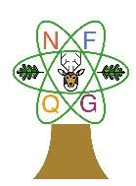
New Forest Quilt Group
Newsletter January 2021

Chairman’s Chat

It must have been very difficult for many of you, with the enforced restrictions, over the last ten months but I do hope you managed to enjoy Christmas Day in some way. It wouldn’t be the same without the old, familiar films such as “It’s a wonderful life” and “White Christmas”. Thank goodness for the Two Ronnies and Morecambe and Wise too! How talented they all were. It was only after years of the Two Ronnies performing we discovered Ronnie Barker had written their scripts and also those for many other shows. One evening the team of the Two Ronnies invited the script writer for a meal but his chair remained empty- eventually Ronnie B had to admit he was the creator!

I think we can look back and be proud of what New Forest Quilt Group managed to do before lockdown. Our 2019 Ruby Exhibition was a sterling achievement and all credit goes to Annie Forster who coordinated it so well. The Committee and members all pulled together so well. Ladies had spent months (or years) making all the beautiful quilts, wall hangers, cushions and bags for display. Carol and Sheila got the publicity just right, so we had the necessary footfall throughout the Bank Holiday weekend. The displays, tombolas, traders and varied stalls meant the public were very happy and all these contributed significantly to the final sum. Members stepped up to volunteer for all the necessary roles and cover all the jobs for the whole weekend.

Pat had collected an amazing array of items to sell on her sales table and was a main contributor to the total. Liz insisted we self cater and that enabled us to make far more money to hand over to the two local Air Ambulances. Cake contributions from our members were so delicious and a sit down in between, much appreciated by our visitors. Thank you also to all the members who spent time washing up by hand as the dishwasher was broken. I only hope we can live up to the very high standard next time we have an Exhibition.

The other achievement you can all be proud of is the raffle money raised (without the exhibition) during 2019 and the three months of 2020 when we could meet. All the raffle prizes were donated by members and enabled us to present a cheque for £600 towards the Lymington Hospital scanner during the recent lockdown. We also collected some of the remaining craft items from Pat McKean and gave them to the League of Friends to sell. So, thanks to the efficiency of our new Treasurer, Denise, we have now paid all Charity money owing and can start with a clean slate this year.

My husband Chris, recently took over as Chairman of the Arts Society and has arranged monthly lectures to be on Zoom whilst we are all in lockdown. I have to say enjoying them from the comfort of our armchairs has been excellent. We have even signed up for a season of Blue Badge tours of London, all have been excellent and so enjoyable when we can’t get out. If any NFQ members are interested, please email me on jempy@live.co.uk, call on 01425 620680 or text me on 07776 021033.

Zoom “Show and Tell” on Friday 5th February at 3 pm

We are going to be hosting a Show and Tell via Zoom on Friday 3 Feb 2021 at 3 pm for you all to show off your makes of the last year. I will email everyone an
invitation to join in via Zoom. This has a 1 button invitation which you tap on to join in, if you don’t have the app already, do download it so you can join in and sort out your quilts for all to admire.

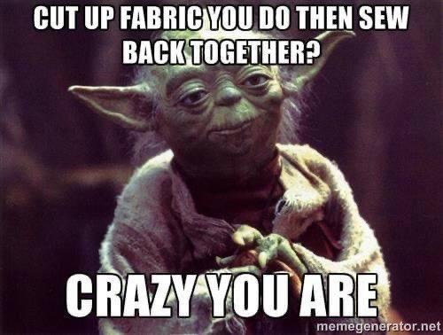

Proforma to decide the future plan for New Forest Quilt Group in 2021

Please tick/cross to make your preferences known:-

1. I will/ will not be happy to return to the Community Centre as soon as it opens with social distancing in place.
2. I have a computer with the free Zoom app loaded and would like to join members in that way/ I don’t have a computer/ I have a computer but need help to access Zoom.
3. I would prefer to take part on Zoom from home until it I feel safe to meet in larger groups.
4. If New Forest Quilt Group have to arrange their speakers online, until it is safe for them to come to New Milton, I will be able to access those on Zoom.
5. I would like to help out in some way

Please ring any of the following that you would be happy to do or cross out those you do not want to do (or have already done and do now wish to do again):-

1. be an occasional library volunteer
2. help run the raffle
3. help the speaker or trader set up
4. help the speaker or trader pack away
5. help ring a small group of members locked down at home
6. join the Committee as a general helper
7. join the Committee and help with the role of Workshop Secretary.
8. other.....your suggestions please.
Please return this proforma either by email to jempy@live.co.uk or by mail (15 The Fallows, New Milton, BH25 5RP) so that the Committee can get NFQ Group going again this year.

Thank you.
Jenny Davies

New Forest Quilt Group
Calendar for 2021/2

2021
January | Monday | 4th | Jennie Rayment talk CANCELLED
February | Monday | 1st | Carolyn Forster talk CANCELLED
 | Tuesday | 2nd | Carolyn Forster workshop CANCELLED
March | Monday | 1st | AGM
April | Monday | 5th | Easter Monday
 | Monday | 12th | Catherine Lawes talk CANCELLED
 | Tuesday | 13th | Catherine Lawes workshop CANCELLED
 | Monday | 12th | Journal Quilt Challenge exhibition, and exhibition of members’ work during lockdown
May | Monday | 3rd | Bank Holiday
 | Monday | 10th | Annabel Wilson talk – “Creating with Shibori”
June | Monday | 7th | Summer Meeting
July | Monday | 5th | Dawn Cameron-Dick talk “One Woman Quilt Show”
 |  |  | Dawn Cameron-Dick workshop “New York Beauty with Invisible Machine Applique”
August | Monday | 2nd | Jackie Dimmock talk “The Good, the Bad and the Downright Funny – my 30 years with the Hampshire Constabulary”
September | Monday | 6th | Sheena Roberts talk “Waddings – how they see, feel and behave”
 | Tuesday | 7th | Sheena Roberts workshop “Simple Stained Glass Wall Hanging”
October | Monday | 4th | Andrea Ashwell talk “From Durham to the Galaxy”
November | Monday | 1st | Christmas Crafts
December | Monday | 6th | Christmas Party
2022

January | Monday | 3rd | Bank Holiday
 | Monday | 10th | Jennie Rayment talk
 | Tuesday | 11th | Jennie Rayment workshop
February | Monday | 7th | Janet Clare talk
 | Tuesday | 8th | Janet Clare workshop
March | Monday | 7th | AGM
April | Monday | 4th | Come and sew / stitch and chat evening

Linus Quilts

Once again Linus has had another extremely busy year in this area despite the difficulties with Covid 19.

Total deliveries in 2020 were 2327 up to November this includes 275 amazing Christmas quilts, which is a fantastic number of quilts donated.

Our quilts are delivered to all the children’s wards in Southampton Hospital including Neonatal and Teenage Cancer Care, Sure Start Centres, Women’s Refuge, Blue Sky, Dorset and Southampton foster carers, Mosaic (a children’s bereavement charity) and also a centre for trafficked women who have become pregnant. Thanks to all of your generosity and hard work we have also been able to take on several more special needs schools this year. We also had a request from a nurse on the elderly care unit at Southampton Hospital for quilts to cheer up their patients as they were unable to receive any visitors, luckily we had been given a large number of very big quilts so they were duly delivered, these however do not get counted in our totals.

We have been very busy throughout the year collecting quilts with lots of enquiries from new people offering their help.

Sadly all of our monthly Linus Coffee mornings had to be cancelled, we realise that everyone is missing our coffee and chat meetings to sew on labels, these will of course start up again once it is safe to do so.
Workshops also had to be cancelled and are also very much missed but again these will be resumed when it is safe to do so.

We have to say a huge thank you to Mandy from Cherry Tree Fabrics, also Nicola and Clive from Nicola’s Fabrics for all of their help, hard work and support throughout this difficult year.

A heartfelt thank you to all the wonderful creative quilters who make and donate quilts, also to everyone who supports Linus with their time and generosity and we wish you and your families a safe 2021.

Lourdes Ball, Kathy Osland-Moore,
Carey Doran and Angela Davis
Project Linus UK Coordinators December 2020
projectlinusuk.org.uk

***********************************************************
Nicola’s Fabrics

I am sure we all breathed a huge sigh of relief when we found out the ownership of Nicola’s Fabrics has been transferred to Kirsty of Created by You in Fordingbridge. Kirsty and partner Nick are still doing click and collect and will be in the shop daily until 13.00.

They are also giving a 5% discount for all who shop with them until the end of January. If you are ordering on line, enter the code B45XEHJ at the checkout. This does not include sale fabrics.

********************************************************************

FREE TABLE
A bow shaped ex boardroom table measuring 8 x 4 foot increasing to 4 foot 6 inches in the middle. Available after Christmas. Buyer collects. Please ring Sue Elmer on 01590 641664

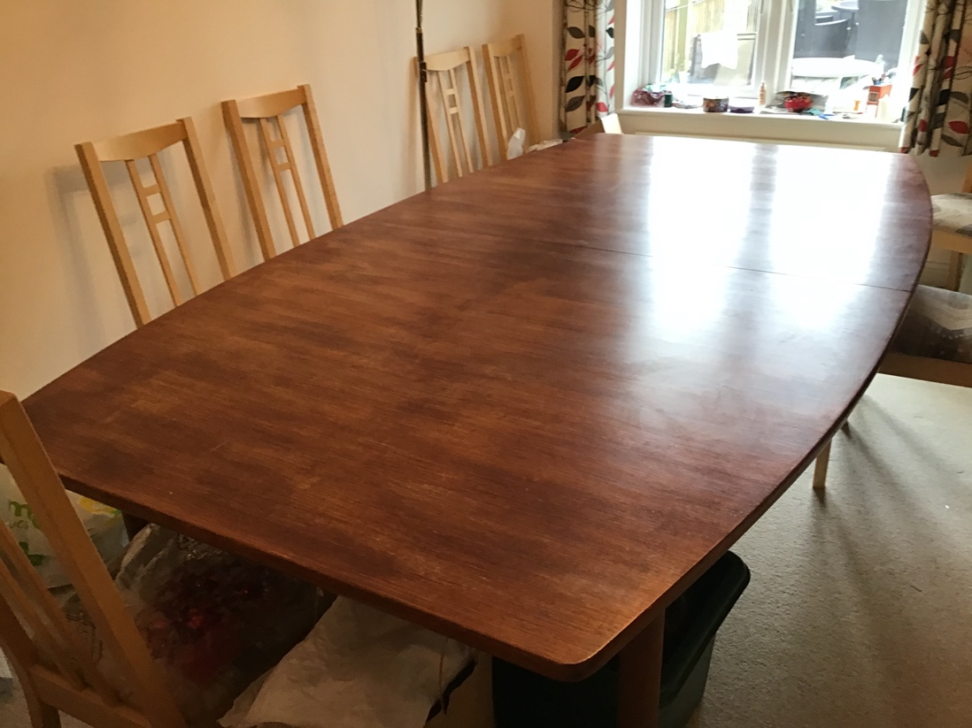

****************************************************************

Quilts for Care Leavers

It was a bumper year for Q4CL this year, with over 1,000 quilts distributed in 2021. So very many thanks to all who contributed fabric, donations, quilt tops and completed quilts.

This year there will be 3 call-ins for quilts, rather than leaving it all to the end of the year. The first one will be the end of March, (Covid permitting) so if you have a completed quilt, please drop it round to me and leave it in my porch before then,

It has not been possible to fund raise as it was last year, so all tops have had to be sent with backing fabric, completed binding and a £7 charge towards wadding and thread. I had some very generous donations and have managed to cover this cost for 2020.
I also have a good-ish selection of backing fabrics and fabric to turn into binding, so if you have a completed top, and need backing and binding, please get in contact and I can leave some appropriate fabric out for you.

Any quilt tops dropped off which need to be quilted will need to come with a £7 donation for the cost of thread for the long arm quilter. Please safety pin envelope to the quilt.

Size of quilts needed

We are making for young adults aged 18 – 25, so please keep this in mind when selecting fabric.

Width between 40” and 50”
Length between 66” and 70”

Quilts need to be oblong, to provide that feeling of a hug.

Please, quilting cotton only, we cannot accept quilts containing upholstery or curtaining fabric or any type of licenced fabric.

Many thanks

Eleanor

Thank you to everyone who has contributed to this month’s newsletter. If you have any items of interest to our members, please email them to Eleanor at eleanor.dowe@gmail.com. Don’t forget to visit our website at www.newforestquiltgroup.weebly.com and join our New Forest Quilt Group Facebook Page.

