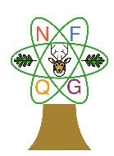
New Forest Quilt Group
Newsletter October 2020

Chairman’s Chat

I do hope all our members are keeping safe and busy. Hopefully you managed to see some of your friends and family while the weather has been kind and we were in Tier 1. We will need the good memories when we have to spend most of the time indoors over the winter and in another lockdown following the second spike.

Maybe you can work on your Journal Quilts while you are indoors, ready to show the group some time next year. By now the four mainly purple and the four mainly yellow should be nearing completion. However, if anyone would like some purple or yellow fabric to get started, I am happy to drop some in for you. Please contact me.

In November we need to start trying out our ideas for the four mainly green ones. I am really looking forwards to seeing them all. Judging by the ones I have seen in person and on our Facebook page, they are all very different, showcasing varied embroidery, patchwork, appliqué and quilting skills.

My nieces have just inherited their Mum’s complete stash recently and I have been most impressed by their leap into Patchwork. The elder one, Jeannette, put me onto Moda Blockheads. She has made a “quilt as you go” double bedspread with all her Moda Blocks. Her husband said it was very comfortable with just that and a sheet on top of them during the very hot weather. Ladies‘ Moda blocks regularly appear on my Facebook page - all very different - but fascinating to see. If you are keen to make different blocks regularly these are a great idea.

Finally the Community Centre scaffolding has come down, so I assume the roof is now repaired. Language classes have resumed. I now learn Spanish in a larger room, facing each other, socially distanced. We all wear masks. It is almost impossible to tell what the ladies are saying in Spanish muffled by the mask! Still it is good to return to some normality. The Community Centre AGM is coming up and our Treasurer, Denise Mangles, will join it and feed back what their future looks like.

As our workshops and Sandown trip have not been able to go ahead, your Committee are in the process of returning all the deposits you paid in advance. We miss all the lovely events we normally attend and hope they can resume some time next year. It all depends on this second spike.

Denise and I travelled to Lymington Hospital to present the cheque raised by all the raffle prizes and material you donated. Penny Hebditch waived her fee so that is also included, plus final sales from the Exhibition Sales table. We have raised almost £600 between January 2019 and March 2020. The hospital League of Friends are delighted to receive this towards their scanner appeal.

Jenny

**************************************************

From Speakers’ Corner….

As this funny old year draws to a close it seems less and less likely that we will be able to return to normal by the time our March meeting/AGM comes round. But it’s not over till the large lady sings, as they say, and your Committee is continuing to plan ahead for 2021 and beyond.

The programme for next year is looking something like this:

Monday  1st March  2021 | 7pm | Annual General Meeting  A chance to catch up with fellow members and elect/re-elect officers | New Milton Community Centre
Monday  12th April  2021 | 7pm | Show and Tell  Journal Quilt Challenge exhibition and exhibition of members’ work during lockdown | New Milton Community Centre
Monday  10th May  2021 | 7pm | Monthly Meeting  Our speaker is Annabel Wilson “creating with Shibori” | New Milton Community Centre
Monday  7th June 2021 | 7pm | Summer Meeting  Strawberries and scones, tea and lemonade, chat and creativity | New Milton Community Centre
Monday  5th July  2021 | 7pm | Monthly Meeting  Our speaker is Dawn Cameron-Dick “One Woman Quilt Show” | New Milton Community Centre
Tuesday  6th July  2021 | 10am – 4pm | Workshop with Dawn Cameron-Dick | Mary Magdalen Church Hall
Monday  2nd Aug  2021 | 7pm | Monthly Meeting  Our speaker is Jackie Dimmock “The Good, the Bad and the Downright Funny” | New Milton Community Centre
Monday  6th Sept  2021 | 7pm | Monthly Meeting  Our speaker is Sheena Roberts | New Milton Community Centre
Tuesday  7th Sept  2021 | 10am-4pm | Workshop with Sheena Roberts | Mary Magdalen Church Hall
Monday  4th Oct  2021 | 7pm | Monthly Meeting  Our speaker is Andrea Ashwell “From Durham to the Galaxy” | New Milton Community Centre
Monday 1st Nov  2021 | 7pm | Monthly Meeting  Christmas crafts. | New Milton Community Centre
Monday  6th Dec  2021 | 7pm | Christmas Party  Fun quizzes, competitions, lemonade and mince pies, and crackers! | New Milton Community Centre

Obviously this is all dependent on the pandemic situation; as always the committee’s first priority is the safety and comfort of our members. But fingers crossed……..

Terry
Speaker and Workshop Secretary

**************************************************
New Forest Quilt Group were pleased to present Lymington Hospital’s Friends a cheque for £600 to augment their appeal for the upgrading of the Imaging Suite with a new MRI scanner. Jenny Davies presented the cheque to trustees: Anne Bowman and co-chairman, Arthur England.

The money collected represents the generosity of members over 15 months of raffles, gift donation, fabric donation and the waiving of speaker fees by a member in order to support this excellent local charity.

In addition to their cash donation, Jenny and Denise brought some extra crafty items to sell in the hospital foyer.

Arthur England (Joint Chair of LHF) commented. “We are so pleased to work with local community groups and it’s really great to meet Jenny and Denise today to receive their donation and learn more about the work of the NF Quilt group. Thank you so much to all of your members for their hard work making crafts to sell to support the hospital and other local charities. This donation will go towards new imaging equipment that is much needed to enable the hospital to continue to improve patient assessment care.

Charity Gift

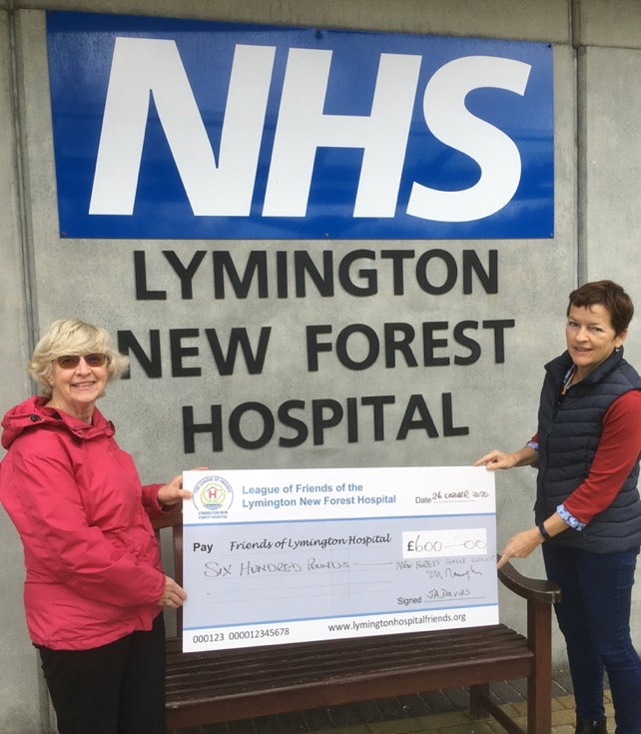

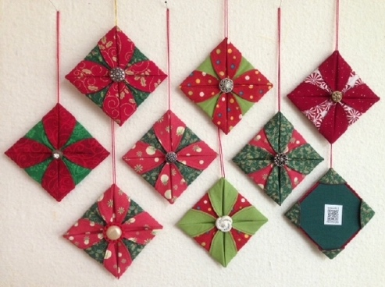
Origami Folded Fabric Ornaments

Take two, freshly pressed, coordinating Christmas fabrics and place them right sides together on a flat surface so that the straight grain is running the same way in both fabrics.

Trace around a bowl or saucer with a thin permanent pen, cut the shapes out and hand or machine stitch RIGHT sides together. Don’t leave a gap for turning.

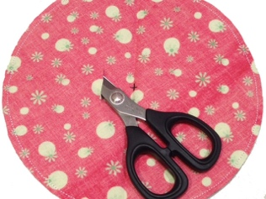
Fold the circle into quarters to find dead centre. Make a 1″ slit in ONE fabric 1″ away from the marked dead centre.

Turn the disk right-side out. Push out seam allowance with chopstick, wiggle the two fabrics back and forth at the seam to draw out any hidden creases. You can also pick them out with a pin.

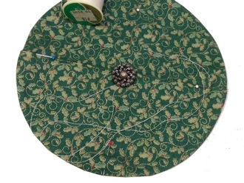
Sew a shanked button to the non-slit side, dead centre. Knot off the thread after sewing on the button, but leave a very long tail.

Crease the disk in half then half again. Pin or mark the edge of the disk where the creased line meets the edge. Fold one side of the disk into the centre and secure with a stitch next to the button.
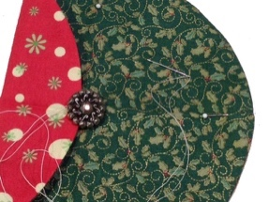
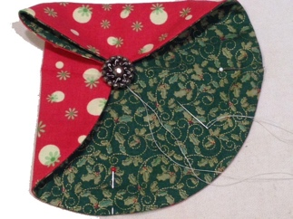
Repeat three times, take thread
to the back and knot off.
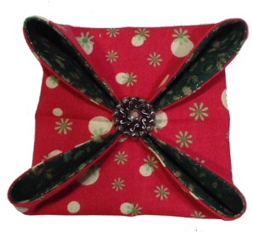

Press the sides, then fold over and press the point with your iron.
.
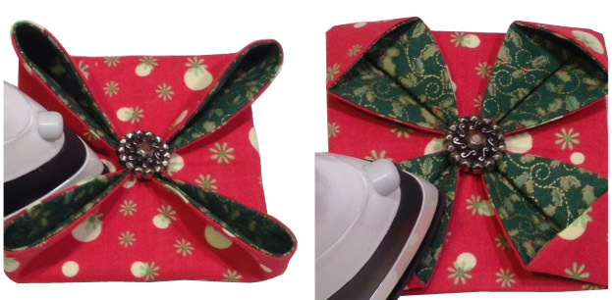

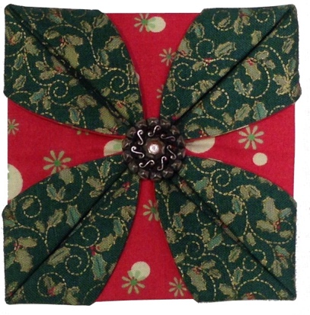

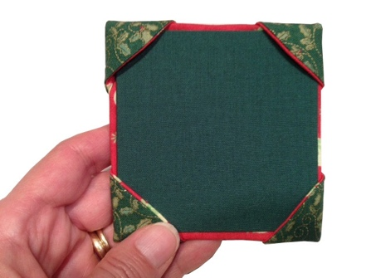
Flip / fold the corners to the back of the
ornament and press.

Cut and cover a piece of cardboard to
fit the back of your ornament and
tuck it into the four corners.

Finally, stitch a piece of ribbon to one corner and hang on your tree…….. or use as a gift label!

With acknowledgment and thanks to Ami Simms (amisimms.com)

********************************************************************

Quilts for Care Leavers

Very many thanks to those who have dropped off completed quilts to me for Q4CL. These have had their labels and I am waiting to know where they are to go. If anyone else has a completed quilt, could you pop it in to me next time you are in Lymington. I leave the porch open for deliveries and there is hand sanitiser there as well! We currently have 37 ready to go!

We have sent 19 quilt tops off for long arm quilting, and I am gradually receiving photos back of them. This year, it has not been possible to fund raise as it was last year, so all tops have had to be sent with backing fabric, completed binding and a £7 charge towards wadding and thread. I have had some very generous donations and have managed to cover this cost for this year.

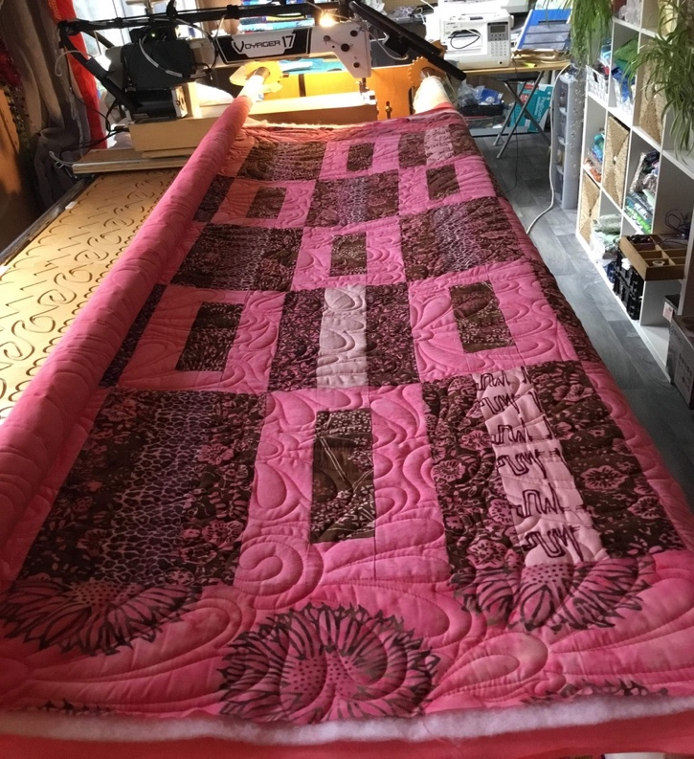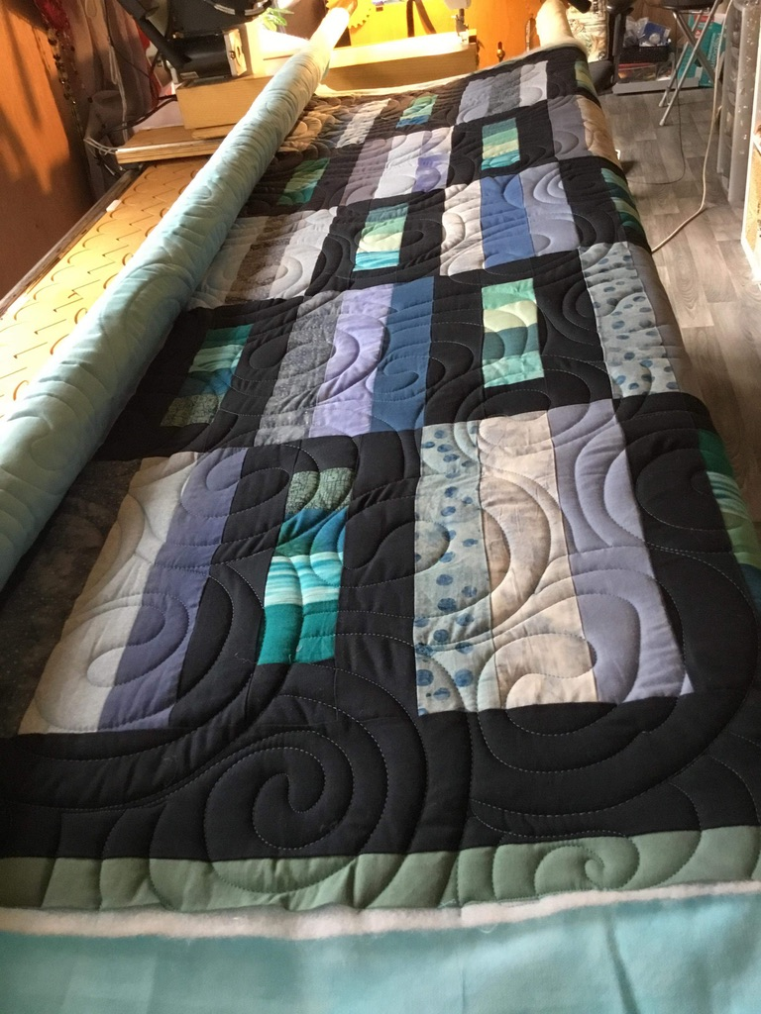
It does not look likely that many dinners will go ahead this year, but the quilts will still be gifted to care leavers, so they will all find a welcome home.

Eleanor

Thank you to everyone who has contributed to this month’s newsletter. If you have any items of interest to our members, please email them to Eleanor at eleanor.dowe@gmail.com. Don’t forget to visit our website at www.newforestquiltgroup.weebly.com and join our New Forest Quilt Group Facebook Page.

